**

## **CORONAVIRUS – Minibus Capacity Guidelines for Hire & Tours.**

### Date Added 01/06/2020

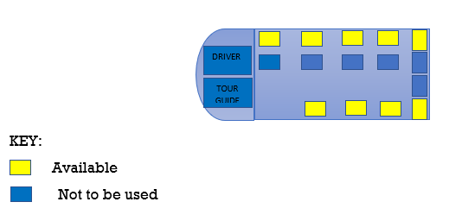

This document is correct at Monday 1st June 2020 and should be read in conjunction with our ‘Terms & Conditions’ document as published on our website.

Throughout this pandemic period, and in the transition as we return to normal operation, it is very important that we follow some simple guidelines to protect our staff, you and your passengers - and anyone else that we may come into contact with as we carry out minibus/tour travel services for you.

Transport is vital to support our economy and public services and we want to work closely with yourselves to ensure a safe system of work for all passengers and for our staff.

We are committed to proactively reducing the spread of any disease and maintain the health of our staff and passengers.  As such, you as passengers are urged to follow this guide to help maintain the hygiene levels that we have in place to reduce the spread of any disease.

**PASSENGER CAPACITY GUIDELINES FOR MINIBUS**

The following guidelines are based on the current official government guidelines and are also based on the measures identified and required through our Covid:19 Risk Assessment, a copy of which can be provided upon request.

The primary concern on board our minibus is that of social distancing; all passengers should keep their distance from people outside their household, and we recognise that this is not always possible. The transmission of Coronavirus is primarily through people touching surfaces contaminated by the virus and then transferring that contamination to their mouth, eyes or nose. There is also a possibility of breathing in droplets expelled by another person when in close face to face contact.

With these facts in mind, please be assured that your minibus will arrive in a sanitised, virus free condition; and that we have the following measures in place prevent the spread of the virus during coach hires. Furthermore these protocols comply with World Health Organisation guidelines, which are fully achievable on our minibus. Our normal front facing seating arrangements avoid ‘face to face’ proximity and the physical barrier of the high raised Perspex backed dividers on seats, plus the use of face coverings and masks will all help to ensure maximum safety.

**In order to set out passenger capacity recommendations for our minibus, the following provisions and policies are in place during the course of this pandemic.**

1. Our minibus has forward facing, high raised Perspex dividers on the back of seats, which do create an important physical barrier between passengers.  And passengers will be seated on alternate seats on each row.
2. All passengers will be requested to wear a face covering, preferably their own, however our drivers will carry a stock on board.
3. Our minibus cleaning system includes daily cleaning of all floors, seats and all glass surfaces, mopping with disinfectant of all floor surfaces, disinfectant wiping of dash areas, driver controls and handles. It also includes cleaning all hard surfaces, handrails, hand grabs, seat belt buckles, armrests and floors between all journeys and also includes vehicle anti-viral fogging on a daily/weekly basis, depending on use.
4. All passengers should look to maintain at least 1 metre distance from each other during all boarding, travelling and alighting from our coaches.
5. For the on-going safety of our drivers and passengers, the double seat immediately behind the driver will not be available for use.
6. Passengers who live together in the same household, may sit together on a double seat. Where this occurs, the seat opposite, next to the aisle must not be used and some passengers will seated immediately behind each other.
7. Upon boarding, passengers are encouraged to use the hand gel provided on board.

**REDUCED MINIBUS CAPACITY RECOMMENDATIONS**

In view of the above provisions, the recommended capacities for our minibus fleet is as below.  An illustration of the principle of seating 2 passengers per row on alternate seats is also shown below.  This example excludes where passengers who live together in the same household will sit together.

| **NORMAL COACH SEATING CAPACITY** | CORONAVIRUS ADJUSTED PASSENGER CAPACITY  (Generally, all rows are utilised, except the seats behind the driver, as no.6 above). |
| --- | --- |
| 16 seat mini-coach | 9 passengers. |
| 19 seat mini-coach | 11 passengers. |
| 29 seat midi-coach | 13 passengers. |
| 35 seat midi-coach | 16 passengers. |
| 37 seat midi-coach | 17 passengers. |
| 49 seat coach with toilet | 23 passengers. |
| 53 seat coach with toilet | 25 passengers. |
| 57 seat coach with no toilet | 27 passengers. |
| 63 seat coach with toilet | 30 passengers. |

Thank you for your cooperation and support with these important guidelines